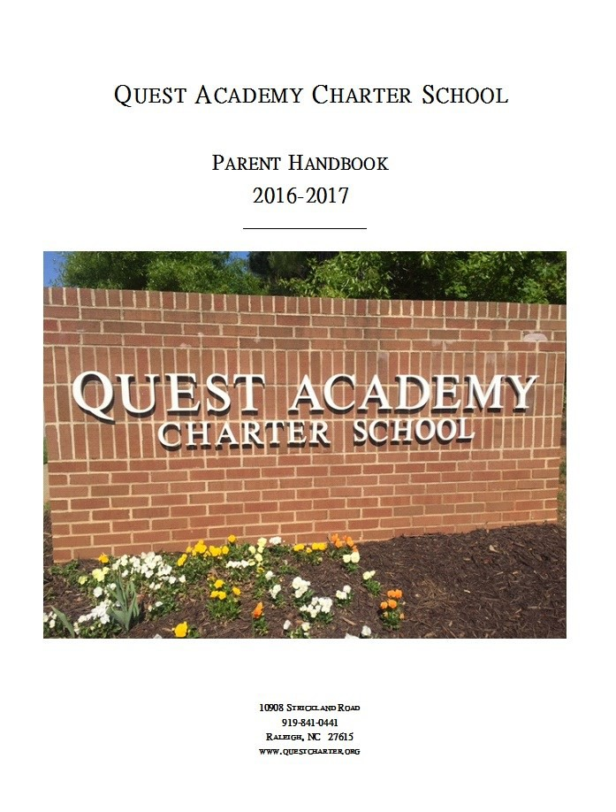
Quest Academy Charter School
2017-2018 Handbook

Table of Contents

Table of Contents 2
Message from the Principal 3
Mission Statement/History of Quest 4
Staff Directory 5
Calendar 6
Activity Requirements 7
Requesting Homework 8
Tardiness 8
Field Trips 9
School Absence 9
Extracurricular Activity 9
Grades and Report Cards 10
Curriculum 10
Arrival and Departure 11
Lunch Schedule 11
Student Pick-up/Event Parking 12-13
Health and Safety 14
Volunteering 15
Fundraiser 16
Inclement Weather 17
Code of Conduct 18-28

2

W e l c o m e T o Q u e s t

On behalf of our faculty, staff and Board of Directors at Quest Academy, I would like to extend a special welcome to our new and returning families for another school year. Our faculty and staff at Quest Academy have combined important school information into a single document we think will be useful and convenient throughout the year. Please read the entire document and keep it in a convenient location for reference during the year.
3

History of Quest
Quest evolved from a private school known as the Helen Paesler School. In 1993, the Helen Paesler School opened to accommodate the rigorous training schedule of the gymnasts participating in the Gymcarolina competitive team program. The goal was to provide a high quality education that would be flexible to the demands placed on these children in pursuit of their chosen interests. Through a shortened, more intensive school day and a year-round academic schedule, the Helen Paesler School sought to ac- complish its goal. Helen Paesler became Quest Academy in 1999, continuing the mis- sion and schedule.

The Mission Statement
The mission of Quest Academy will provide a quality academic accelerated day pro- gram for motivated students who are pursuing high intensity training outside the class- room. Quest Academy is designed to promote academic excellence and substantial extracurricular involvement in athletics or performance in fine arts. This activity does not equate with religious or youth activities and include professional instruction outside of the home.

Staff Directory

Administrator . . . . . . . . . . . . . . . . . . . . . . . . . Elizabeth Readmond
Administrative Assistant . . . . . . . . . . . . . . . . . . . . . Jackie Williams
Administrative Assistant. . . . . . . . . . . . . . . . . . . . . Caroline Russell
Testing and Technology. . . . . . . . . . . . . . . . . . . . . . . . Jackie Alluisi
Special Programs . . . . . . . . . . . . . . . . . . . . . . . . . . . . . Lynn Orlando
Kindergarten . . . . . . . . . . . . . . . . . . . . . . . . . . . . Katherine Fischetti
Grade 1 . . . . . . . . . . . . . . . . . . . . . . . . . . . . . . . . . . . . . .Amber Reid
Grade 2 . . . . . . . . . . . . . . . . . . . . . . . . . . . . . . . . . . . Laura Zielinski
Grade 3 . . . . . . . . . . . . . . . . . . . . . . . . . . . . . . . . . . . . . Karen Blalock
Grade 4 . . . . . . . . . . . . . . . . . . . . . . . . . . . . . . . . . . . . Amanda Damar
Grade 5 . . . . . . . . . .. . . . . . . . . . . . . . . . . . . . . . . . . . . . . . . . Ali Patno
Grade 6 . . . . . . . . . . . . . . . . . . . . . . . . . . . . . . . . . Patrick O’Connell
Grade 7 . . . . . . . . . . . . . . . . . . . . . . . . . . . . . . . . . . . . . Robin Thoman
Grade 8 . . . . . . . . . . . . . . . . . . . . . . . . . . . . . . . . . Shana McMasters

Board of Directors
President . . . . . . . . . . . . . . . . . . . . . . . . . . . . . . . . . . Mr. Brock Lavrack
Mr. John Medicke Mrs. Libby Emswiler Mrs. Loren Hatfield Mrs. Tammy Vinson

Activity Requirements

The mission of Quest Academy is to provide a quality, accelerated academic program for mo- tivated students pursuing high intensity training outside the classroom**. The students may be involved in athletic participation or performances in fine arts. The activity does not equate with religious or youth activities and should include professional instruction outside of the home.
**The purpose of the condensed day is to allow for high intensity training outside the class- room.
So what does that mean? Your child needs to be in an activity for the given amount of hours designated by grade each week. Ice Hockey, Figure Skating, Gymnastics, Swimming, Soccer, Tennis, Tae-Kwon-Do, Horse Back Riding, Football, Baseball/Softball, Basketball, Golf, Ballet/ Dance, Piano, and Acting/Theater are all activities which fall under our mission. Boy Scouts, Girl Scouts, Indian Princess, Indian Guides, Church Choir, Church Youth Group, Art Classes do not fall under our Mission Statement.
If you are not sure about your child’s activity, please feel free to come by and ask. At the end of each quarter, we will be sending home an activity letter , to be filled out and returned
with your child’s activity and signed by the instructor.

Requirement hours for outside participation are as follows: Kindergarten: a minimum of one and a half hours per week Grades 1 and 2: a minimum of 3 hours per week
Grades 3-8: a minimum of 5 hours per week

Requesting Homework
To request homework for a child who is sick, please call the school in the morning. The teacher will be notified and all assignments will be ready at the end of the school day. Pull- ing together class assignments for an absent student at the beginning of the school day takes away teaching time from the other students.

Tardiness
If your child arrives to school late, it causes a disruption to classroom instruction for the stu- dent as well as the rest of the class. Sign your child in at the front desk. Parents should not accompany their child to the classroom, as it will add to the distraction of valuable class time. If you need to communicate with the teacher send a note with your child.
Students with excessive (3 or more) tardies a quarter will be referred to the principal who will contact the parent/guardian and establish an attendance improvement plan.

Field Trips
The individual teachers plan field trips related to various subject areas. Prior to any field trip, a note is sent home with each student describing the trip and explaining any fees in- volved. This note includes a permission slip that must be signed by the parent and returned to the teacher. Any parent or adult who volunteers regularly with students must have a criminal background check. Parents who volunteer as chaperones on field trips must go through the Caroli- na Investigative Research before going on a field trip.

School Absence
Students are expected to be in attendance every day school is in session. Family vacations, camps, etc. are not reasons for excused absences. When a student’s absence is unexcused, prior assignments nor make-up work will be provided. Family events should be scheduled during school breaks so as not to compromise the quality of your child’s education.

Extracurricular Activity Absences
Absence because of the student’s pursuit of their chosen activity outside school can be ex- cused when the parent submit the appropriate form outlining the necessary information. Forms for this purpose are available at the front desk and must be submitted to the princi- pal at least five (5) days before the requested days of absence. During the absence, the stu- dent is responsible for the work missed at school.

For an absence from school to be excused, the activity must be sponsored by or re- lated to the student’s chosen activity as outlined in the application to attend Quest Academy.

Grades and Report Cards
Report cards are given on the last day of each quarter. The grading scale is as follows:

Grades 3 - 8

A | 93 -100
B | 85 - 92
C | 77 - 84
D | 70 - 76
F | Below 70

Kindergarten—2nd Grade
M Most of the Time
S Some of the Time
N E Needs More Experience

Curriculum
Quest Academy endorses the Common Core State Standards. These standards provide a consistent, clear understanding of what students are expected to learn, so teachers and parents know what they need to do to help them. The Common Core State Standards build upon the strength of current standards to boost the competitive advantage of Amer- ican students, who for the first time will have the opportunity to meet the academic standards set by top-performing countries.

Arrival and Departure Procedures
Our school day for students begins at 8:30 a.m. and ends at 1:30 p.m. Please note no one will be available to supervise your child before 8:15 a.m. each day. Therefore, we ask that you not bring your child(ren) to school before 8:15 a.m.

When students arrive at school, they should go immediately to their classroom. If a child arrives at school after 8:30, an adult must sign them in. Following dismissal, students should not be on campus after 1:45.

Lunch Schedule
Lunches prepared at home should be brought to school by the student. However, lunch- es brought to school by a parent need to be dropped off at the front desk at least 15 minutes prior to the lunch period. This will allow the lunch to be delivered to the student in time for lunch and classes will not be interrupted.

Grades 5-8 11:00-11:30

Grades 3-4 11:20-11:50

Grades K-2 11:40-12:15

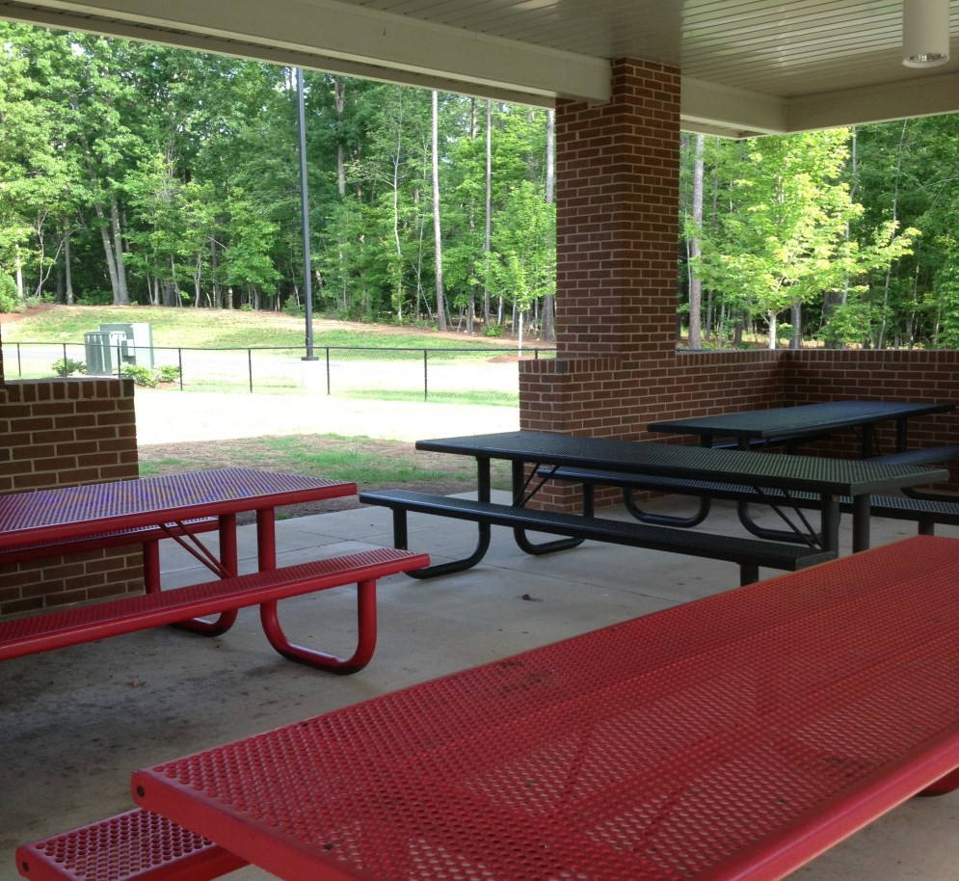

Morning Drop-off of Students

All students will be dropped off at the covered area on the East side of the school. Only the inside lane will be used for drop off. Do not drop off students from the outside lane. Make sure your student is under the canopy before you begin to move. It is imperative that parents follow the guidelines to help insure the safe drop off and pick up of students. Once you have dropped off your student, proceed to the exit and move to the appropriate lane based on whether you are turning left or right onto Strickland Road. Once dropped off, students will proceed to walk to the front door to enter the school. For safety purpos- es the side doors will always be locked from the outside.
If a parent has a conference or particular reason to accompany their student into the build- ing, turn in front of the building just after entering the property and park and walk with your student at the front entrance. We only have 22 parking spaces and 13 of those will be used by faculty and staff.

Afternoon Pick-up (Grades 1-8)

All students will be picked up at the covered area on the East side of the school. When you enter the school campus, proceed straight ahead around the back of the school while getting into the left or right lane based on whether you will turn right or left onto Strickland Road when exiting the campus. There will be a single solid white line indicating where you are to stop for pick up. By moving to that single line, others will be able to get into position for picking up as well. Our students will know that they don’t go to their car until directed by the faculty member monitoring the pick-up process. While we will be able to have six cars in front of the pick-up area, all students will go from the covered area to their cars from the center at the direction of the faculty member.

Afternoon Kindergarten Carpool
If you will be picking up a kindergarten student , when you enter the campus, turn in front of the school and proceed to the solid white line at the end of the building. The kindergarten teacher will have her students under the pick-up area ready to be picked up. It is important the cars are in a single file since we will load our young student’s one car at the time so the kindergarten student can get into the car from the driver’s side, so the kindergarten student can get into the car from the driver’s side. Parents providing carpool for an older student as well as kindergarten student will use the kindergarten line. When you have safely loaded the students you pick up, move ahead and safely merge with the other parents from the left, getting in the left or right lane based on whether you will turn right or left when entering Strickland Road.
No student will go to their car at any other point or without permission from the faculty member.

Event Parking

Do not park on the lanes going around the back of the school between the hours of
8:00 A.M. until 8:30 A.M. and 1:00 P.M until 1:30 P.M. for any reason. Students are being dropped off or picked up during these times. At other times when you are attending a school event, enter the school site from Strickland Road, stay in the right lane going around the back of the school and come to a stop near “student pick-up” where the word “STOP” is painted on the asphalt. This is where the first car would park and each car thereafter should park in the same right lane leaving enough space to get out but not more that need- ed. This will allow for maximum use of the parking lane. The left lane will be used for traffic to leave early or other traffic to get by. We may at times use the front drive for parking, but that will only be used if needed and by instruction only. We are required to leave one lane open for fire vehicles.

Handicapped Parking

The handicapped parking spot in the front of the building is designated ONLY for vehicles with a valid handicapped plate or placard.

Loading and Unloading

The marked Loading and Unloading spot is designated for short term parking. The loading and unloading space is to be used for dropping off or picking up students from school, as well as dropping or picking up materials.

Health and Safety

Parents will be called if a student becomes ill, or have symptoms of illness (vomiting, diar- rhea, abnormal temperatures at school. Students who have been ill, should stay home un- til they are symptoms free of illness, fever, vomiting, diarrhea, etc. are gone for 24 hours.

Medication Policy
Medication is not allowed in school without prior approval. All medications, both prescription and over-the counter, are to be brought in the original container, with the name of the student, the name and dosage of the medication, instructions for administration, and physicians name. The medicine must accompany the Physician Authorization Form. No medicine will be given without a physician’s order. This includes aspirin/ibuprofen prod- ucts, allergy medication and cough drops. The form can be downloaded at www.questcharter.org or from the office.

Emergency information

Locator Card

When students first enter school, parents are asked to complete Locator Cards giving information about how to contact a parent in case of an emergency, as well as designate people who can be called in the event parents cannot be reached. Parents are also responsible for updating information on the Locator Card if any of the information should change. (Please make these changes with the office staff.) Only those individuals listed on the Locator Card as authorized may pick up a child from Quest.

Volunteering

Quest Academy Charter School requires all volunteers to undergo a criminal background and driving record check. An outside investigative research firm will conduct these background checks. The information collected will be verified by this agency. Volunteers, whose history, including criminal history, demonstrating a risk to the safety or well-being of students, will be denied participation in volunteer activities at Quest Academy.
Quest Academy Charter School has developed guidelines regarding what are acceptable and unacceptable criteria for volunteering at the school. The following conditions will result in the automatic exclusion from the volunteer roster:
Providing false information on the volunteer application
Conviction of or plea of no contest to any felony
A registered sex offender or any sex crime charges
Conviction of or plea of no contest to any misdemeanor
Any current pending criminal charges
- or more of criminal charges without conviction (i.e. dismissed)
- or more traffic violations (which reflect disregard for the safety of self and others) within the past five years
Revocation or suspension of a driver’s license within the past 10 years One or more driving while impaired convictions within the past 10 years
Volunteers who are cleared through the background check will be notified via e-mail and placed on the Quest volunteer roster. Once approved, the agency will enroll each volunteer in a monitoring system which routinely monitors those in the data base for future offenses during the time they are volunteers at Quest. An applicant whose record identifies any of the unacceptable criteria may contact the agency directly to provide any corrections to the information used to make the determination or to provide extenuating data.
Once approved, all volunteers will sign in when arriving at the school. At that time they will inform the office of where they will be during their visit, and will be asked to wear a school- developed volunteer tag while participating in volunteer activities. Volunteers need to sign out when they leave Quest.
The background check will cost $13.95 and will be conducted by BIB. You can go onto the website and submit your information at anytime.

**** Quest will not be logging volunteer hours for the 2017-2018 school year. Friends of Quest ( FOQ) will be requesting the majority of parent volunteers.

Fundraiser

As a convenience to all parents and in keeping with our focus on student studies instead of solicitation, we ask for your annual fundraiser donation of $100 per student. This request is made one time a year; however, donations may be divided up throughout the year and can make your donation through Paypal. Each monetary gift is important and we look forward to your continued support.
Charter Schools do not receive the same per child funding as traditional schools and do not receive money for capital spending. We continue to keep the latest technology in the class- rooms for teachers and students. With your support, all the contributions go directly to sup- porting the instructional program.

For income tax purposes, the school is a 501C non-profit corporation. All contributions are acknowledged with a written receipt for your records.

Inclement Weather

Quest has subscribed to an automated call service to call all parents in the event of an emergency such as a weather delay or cancellation. Also, Quest will announce closings on WRAL- TV5.
We will use our automated service to get important messages to our parents during the school year, particularly when time is of the essence not weather related.

Contact numbers for the automated system are taken straight from the locator cards. Parents are responsible for updating information on the Locator Card. Please make these changes with the office staff. If you would like to have another number added, please let the office know.

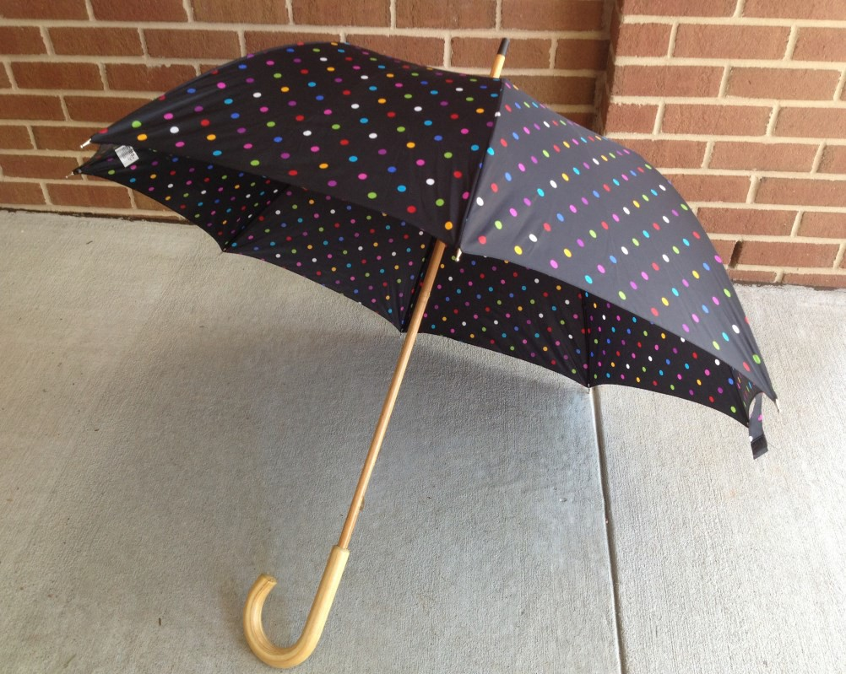

17

Code of Conduct

All students shall comply with the Code of Student Conduct of Quest Academy Charter School, and all state and federal laws. This code applies to any student who is on school property, who is in attend- ance at school or at any school-sponsored activity, or whose conduct at any time or place, on or off campus, has a direct and immediate effect on maintaining order and discipline or protecting the safety and welfare of students or staff in the school.

Student Expectation
Students are expected to be familiar with all rules of behavior in the Code of Student Conduct. Stu- dents are to assist in promoting a safe and orderly school environment. Students are encouraged to report to school authorities any serious violation of the Code of Student Conduct.

Range of Disciplinary Actions
Violation of the Code of Student Conduct or North Carolina General Statutes may result in discipli- nary action. Students shall be informed of school rules that, if broken, may result in short-term suspension or long-term suspension.

A serious violation of any of the policies listed in this Code of Conduct may result in long-term sus- pension of a student. Repeated violations of this code may subject a student to long-term suspen- sion or expulsion.

Reporting by Administrator or School Staff
When a student has violated a school policy that may also be a criminal violation, the school official shall report such violation to the proper law enforcement agency when in the judgment of the school official such a report is in the best interest of the school community or is necessary to main- tain order and discipline. In such cases, school officials shall cooperate fully with the law enforce- ment agency. Internal disciplinary proceedings shall proceed independently from the criminal in-
vestigation and prosecution.

When a staff member or administrator has personal knowledge or actual notice that an act has oc- curred on school property involving assault resulting in serious personal injury, sexual assault, sexu- al offense, rape, kidnapping, indecent liberties with a minor, assault involving the use of a weapon, possession of a firearm in violation of the law, possession of a weapon in violation of the law, the school official shall report immediately such violation to the proper law enforcement agency. In such cases, school officials shall cooperate fully with the law enforcement agency. Internal discipli- nary proceedings shall proceed independently from the criminal investigation and prosecution.
The administrator shall notify Quest Academy Charter School Board of Directors of the report made to law enforcement officials pursuant to this policy.

Policies may be modified on a case-by-case basis to conform to the procedures established for the discipline of students with disabilities.

Fighting/Physical Aggression or Assault
Fighting and assaults on students and other people are prohibited. A student who is attacked may use reasonable force in self-defense, but only to the extent necessary to get free from the attack and notify proper school authorities. A student who exceeds reasonable force may be disciplined even though someone else provoked the fight.
- No student shall hit, slap, shove, scratch, bite, block the passage of, or throw objects at another person.
- No student shall take any action or make comments or written messages, which might reasonably be expected to result in a fight.
- No student shall cause or attempt to cause serious physical injury to any student or intention- ally behave in such a manner that could reasonably cause serious physical injury to any student.
- No student shall assault or attempt to cause physical injury or behave in such a manner that could reasonably cause physical injury to any school employee or other adult.

Weapons and Dangerous Instruments
No student shall possess, handle, or transmit any weapon, facsimile of a weapon, or other object that can reasonably be considered or used as a weapon or dangerous instrument. This does not apply to any student who finds a weapon or dangerous instrument on school property or receives it from an- other person on school property and who immediately reports the weapon or dangerous instrument to school or law enforcement authorities.
For the purpose of the Code of Student Conduct, the following definitions apply:
Weapon: any firearm, BB gun, mace/pepper spray, air rifle, air pistol, ammunition, power
loads, fireworks, knife, slingshot, leaded cane, blackjack, metallic knuckles, razors, razor blades (except cartridge razors used solely for personal shaving), box cutter and any sharp-pointed or edged instrument except instructional supplies, unaltered nail files and clips and tools used solely for preparation of food, instruction, and maintenance.
Dangerous Instruments: any object that is possessed, handled, transmitted, or used for the purpose or intent of causing or attempting to cause physical injury.
Facsimile of a weapon: any copy of a weapon that could reasonably be perceived to be a real weapon.
Firearm: any gun, rifle, shotgun, pistol, starter pistol, firearm silencer, or part thereof, or any powerful explosive, including dynamite, nitroglycerin, trinitrotoluene, blasting cap, or any fire- arm or destructive device defined by 18 U.S.C. 921 OR G.S. 14-269.2 (b) and (g).

Inappropriate Student Behavior
Since an educated citizenry is essential to good government and can be attained only in an atmosphere conducive to teaching and learning, Quest Academy Charter School requires the maintenance of good order in the school.

Inappropriate Dress/Dress Code
Students are expected to adhere to standards of dress and appearance that are compatible with an effective learning environment. Presenting a bodily appearance or wearing clothes which are disruptive, provocative, revealing, vulgar, offensive or obscene, or which endangers the health or safety of students is prohibited.
- No spaghetti straps, strapless clothing or halter tops.
- No undergarments/undergarment straps should be exposed, including sports bras.
- Tank top straps must be at least the width of two fingers in all places.
- No bare midriffs, bare backs or see through clothing.
- No short skirts, short dresses or short shorts – regardless of whether leggings are worn.
- The bottom edge of skirts/dresses and shorts should be longer than the end of your fingertips, when shoulders are down and arms placed at side.
- Dresses/skirts/shorts must be the same length all the way around – not higher on the sides.
- Leggings/yoga pants cannot be worn as pants unless a long shirt covers the back and buttocks. Violation of this rule will result in loss of ability to wear leggings at all.
- Activity/athletic wear must be loose and cover the back and butt.
- No sagging pants – pants must be secured at the waist and not expose undergarments.
- No pajamas or slippers, unless as a planned class activity.
- No hats or other head coverings, unless for religious reasons.
- No clothing that advertises products prohibited by law to middle school students.
- No clothing with profane, vulgar or offensive pictures or writing.
If a student’s dress violates this code, Quest Academy staff may require the student to change his or her dress or appearance. Repeated violations may result in disciplinary action.
All dress policy decisions are at the discretion of the Administrator

21

Gambling
Students shall not participate in any unauthorized event, action, or statement that relies on chance for the monetary advantage of one participant at the expense of others.

Inappropriate Literature and Illustrations
The possession of literature or illustrations which significantly disrupt the educational process or which are obscene is prohibited.

Intimidation/Disrespect
Verbal, non-verbal, or physical conduct that interferes with an individual’s learning environment is prohibited. Intimidation, bullying, repeated teasing or taunting, or the use of offensive or degrading language including, but not limited to, remarks that demeans a person’s race, religion, sex, national origin, disability, intellectual ability or physical attributes are specifically prohibited.

Class/Activity Disturbance
Any physical or verbal disturbance which occurs within the learning environment and which inter- rupts or interferes with teaching or orderly conduct of class/school activities is prohibited.

Sexual Activity
No student shall engage in behavior that is indecent, overly affectionate, or of a sexual nature in the school setting.

Noncompliance
Students shall comply with all directions of the administrator, teachers, substitute teachers, administrative staff, and all other school personnel who are authorized to give such directions, during any period of time when they are subject to the authority of such school personnel.

Inappropriate Language
Cursing or use of vulgar, profane, or obscene language is prohibited.

Thief
No student shall steal, attempt to steal, or knowingly be in possession of stolen property.

Tobacco
No student at any time shall possess, smoke or otherwise use any tobacco product in the school building or on the school premises or while attending or participating in a school function.

Threat/False Threat
No student shall make any threat through written or verbal language, sign, or act which
conveys a serious expression of intent to cause harm or violence. Furthermore, no student shall make a false threat of harm or violence, even in jest, which causes or is reasonably likely to cause fear or a disruption to school activities.

Hazing
Hazing is prohibited. No group or individual shall require a student to wear abnormal dress, play abusive or ridiculous tricks on him/her, frighten, scold, beat, harass, or subject him/her to personal indignity.

False Fire Alarm
No student shall set off, attempt to set off, or aid and abet anyone in giving a false fire alarm. No student shall interfere with or damage any part of a fire alarm, fire detection, smoke detection, or fire extinguishing system.

Bomb Threat
No student shall make, aid, and/or abet in making a bomb threat or hoax by making a false report that a device designed to cause damage or destruction by explosion, blasting, or burning is located on the school premises or at the site of school activities

Fire Setting/Incendiary Material
The possession of any incendiary material (including but not limited to matches,
lighters, or lighter fluid) and the use of any material reasonably likely to result in a fire on school property is prohibited unless specifically authorized by school officials

Extortion
No student shall attempt to extort money, personal property, or personal services.

Disruptive Protest
No student on the school campus or on property adjacent thereto shall engage in
any protest, march, picket, sit -in, boycott, walkout, or other activity which has as its purpose the disruption of any lawful function, mission, or process of the school, or in fact creates such a disruption.

Property Damage
No student shall intentionally damage or attempt to damage or deface school property or private property while under school jurisdiction. Any vandalism or inappropriate behavior in the bathrooms (overflowing sinks, throwing paper towels and toilet paper, throwing pencils and pens in commodes, removing soap dispensers and emptying them, or using toilet paper to “roll” the bathroom) will result in disciplinary action.

Aiding and Abetting
No student shall aid or abet another student in violating any rule in the Code of Student Conduct.

Acts of Terror
- Violation of this section may result in suspension from school for 365 days.

- No student shall make a report that he or she knows or should know is false, that any device, substance or material designed to cause harmful or life threatening illness or injury to another person, is located on school property or at the site of a school activity.

School Disturbance
No student shall, by use of passive resistance, noise, threat, fear, intimidation, coercion, force, violence, or any other form of conduct, cause the disruption
of any lawful function, mission, or process of the school.

- No student shall, with intent to perpetrate a hoax, conceal, place, disseminate or dis- play on school property or site of a school activity any device, machine, instrument, artifact letter, package, material, or substance, so as to cause a reasonable person to believe the same to be a substance or material capable of causing harmful or life-threatening ill- ness or injury to another person.

No student shall threaten (or make a report of a threat that he or she knows is false) to
commit an act of terror on school property or at the site of a school activity that is designed to cause serious injury or death to another person, or when the threat is intended to cause a significant disruption to the instructional day or a school-sponsored activity.

Wireless Communication Devices

Except under school staff supervision for instructional purposes, no student shall use, display, transmit or have in the “on” position on school property any wire-less communication device, including but not necessarily limited to : cell phones, pagers, two-way radios, etc. Possession of said items will result in item being confiscated and returned only to the student’s parents.

Personal Electronic Devices
Students may not bring personal electronic devices such as electronic games, CD players, laser pointers, etc. on Quest Academy campus at any time.

Search And Seizure
To maintain order and discipline in the schools and to protect the safety and welfare of stu- dents and school personnel, school authorities may search a student or school computers un- der the circumstances outlined below and may seize any illegal, unauthorized, or contraband materials discovered in the search. The use of hand-held devices to check a student’s person or personal effects is permitted.

As used in this policy, the term “unauthorized” means any item dangerous to the health or safety of students or school personnel, or disruptive of any lawful function, mission, or process of the school, or any item described as unauthorized in the school rules available beforehand
to the student.

A student’s failure to permit searches and seizures as provided in this policy will be considered grounds for disciplinary action. Although not absolute in all cases, a parent will be informed prior to a search.

Personal Searches
A student’s person and/or personal effects (e.g. purse, book bag, etc.) may be searched when- ever a school authority has reasonable suspicion to believe that the student is in possession of illegal or unauthorized materials.

If a pat down search of a student’s person is conducted, it will be conducted in private by a school official of the same sex and with an adult witness present, when feasible.

If the school official has reasonable suspicion to believe that the student has on his or her person an item imminently dangerous to the student or to others, a more intrusive search of the student’s person may be conducted. Such a search may only be conducted in private by a school official of the same sex, with an adult witness of the same sex present.

School Computers
School computers and any data they contain remain under control of the school and are subject to inspection at any time.

Metal Detectors
School officials or law enforcement officers may conduct metal detector checks of groups of individuals if the checks are done in a minimally-intrusive, non-discriminatory manner. Metal detector checks of groups of individuals may not be used to single out a particular individual or category of individuals.

If a school official or a law enforcement officer has reasonable suspicion to believe that a particular student is in possession of an illegal or unauthorized metal-containing object or weapon, he or she may conduct a metal detector check of the student’s person and personal effects.

Seizure of Illegal Materials
If a properly conducted search yields illegal or contraband materials, such findings shall be turned over to proper legal authorities for ultimate disposition
.

Narcotics, Alcoholic Beverages, Controlled Substance, Chemicals, and Drug Paraphernalia

No student shall possess, use, distribute, sell, possess with intent to distribute or sell, or conspire or attempt to distribute or sell, or be under the influence of any narcotic drug, hallucinogenic drug, amphetamine, barbiturate, marijuana, anabolic steroid, other controlled substance, any alcoholic beverage, malt beverage, fortified wine, other intoxicating liquor, drug paraphernalia, counterfeit substance, any unauthorized prescription drug, or any other chemicals or products with the inten- tion of bringing about a state of exhilaration, euphoria, or of otherwise altering the student’s mood of behavior.

For the purpose of the Code of Student Conduct the following definitions apply:
- Possess: having the power or intent to control a prohibited substance and shall include, but is not necessarily limited to the possession of a prohibited substance in a student’s automobile, locker, book-bag, or desk, or on a student’s person.
- Use: the consumption, injection, inhalation or absorption of a prohibited substance into a student’s body by any means.
- Under the influence: the use of any prohibited substance at any time or place when the pro- hibited substance would influence a student’s mood, behavior, or learning to any degree.
- Sell: the exchange of a prohibited substance for money, property, or any other benefit or item of value.
- Distribute: to give, share, or pass a prohibited substance.
Possess with intent to distribute/sell: Intent to distribute or sell
- may be determined from the amount of the prohibited substance found, the manner in
which it was packaged, the presence of packaging materials such as scales, baggies or other con- tainers, or from statements or actions of the student that demonstrate an intent to sell or dis-
tribute.
- Counterfeit Substance: any substance that is described or presented with the intention of deceiving another into believing that it is a substance prohibited under this policy.
Unauthorized Prescription Drug: Any drug or medication that has not been prescribed for the student.

Integrity
Any student who engages in or attempts to engage in plagiarism, falsification, violation of soft- ware copyright laws, or violation of computer access shall be subject to disciplinary action. The following actions are specifically prohibited:

- Cheating – giving or receiving of any unauthorized assistance on academic work.
- Plagiarism – copying the language, structure, or idea of another and representing it as one’s own work.
- Falsification – verbal or written statement of any untruth.
Violation of computer access – willfully, directly, or indirectly, accessing or causing to be ac-
cessed any computer, computer system, computer network, or any part thereof without proper authorization.

Discipline
A school climate conducive to serious study and respect for oneself, other people, and property is essential for a school to meet the needs of youth. The school administrator has the authority and responsibility to take whatever reasonable and legal action is necessary to establish and maintain appropriate student behavior in accordance with board policy and/or provisions of law. These policies may be modified on a case-by-case basis to conform to the procedures estab- lished for the discipline of students with disabilities.

- The teacher has the responsibility and authority for disciplining students.
- It is the responsibility of our school administrator to investigate fully the cases of students re- ferred to the office for misbehavior and to determine such action as deemed warranted.
- If, in questioning a student, the administrator determines that the questioning should be car- ried out by a law enforcement officer, the administrator shall make a reasonable attempt to notify the parents (except in cases of suspected child abuse or neglect by the parent) to give them an opportunity to be present during questioning.
- A student may be suspended from school short-term, for cause, by the administrator in ac- cordance with the provisions of law and/or board policy
A student may be suspended from school long-term, for cause, by the administrator with the prior approval of the Board of Directors in accordance with provisions of law and board policy.

Due Process
North Carolina law requires teachers to maintain good order and discipline in their school. The
law further gives administrators the power and duty to discipline students and to assign duties to teachers with regard to discipline and general well being of students. Suspension from school is a serious measure. Our administrators will utilize every reasonable resource at their disposal to affect another solution to student misconduct.

If the administrator witnesses or is made aware of serious student misconduct and believes that immediate removal of the student is necessary to restore order or to protect school property or persons on school grounds, she/he may suspend the student immediately.
A short-term suspension is removal from school for a period of ten school days or less. The administrator may invoke a short-term suspension after investigating the misconduct, confronting the student with the charges, allowing for the student’s response and contacting the parents. A suspended student will be provided an opportunity to take any quarterly, semester, or grading
period examinations missed during the suspension period.
A long-term suspension is removal from school for more than ten days but not exceeding the remainder of the school year. An appeal must be made to the school administrator within four days and the appeal will be heard by a committee of the Board of Directors.

Rules governing the suspension of exceptional children shall be in compliance with state and federal guidelines.
The removal of a student from class by the teacher, administrator, or other authorized school personnel for the remainder of the class period or school day and her/his relocation on the school
premises shall not be considered a short-term suspension. Although not inclusive, this could includetime outside, in-school suspension, an alternative educational center, or denial of off-campus events.

